Assignment 3-Day 3 BY(KATTA SAI RUTVIK)

CREATE tables

1.air_passenger_profile
create table air_passenger_profile (
profile_id varchar(10) primary key,
password varchar(10) not null,
first_name varchar(10) not null,
last_name varchar(10) not null,
address varchar(100) not null,
mobile_number bigint not null,
email_id varchar(30) not null
);

2.air_flight
create table air_flight (
flight_id varchar(10) primary key,
airline_id varchar(10) not null,
airline_name varchar(30) not null,
from_location varchar(20) not null,
to_location varchar(20) not null,
departure_time time not null,
arrival_time time not null,
duration time not null,
total_seats int not null
);

3.air_flight_details
create table air_flight_details (
flight_id varchar(10) not null,
flight_departure_date date not null,
price decimal(8,2) not null,
available_seats int not null,
foreign key (flight_id) references air_flight(flight_id)
);

4.air_ticket_info
create table air_ticket_info (
ticket_id varchar(10) primary key,
profile_id varchar(10) not null,
flight_id varchar(10) not null,
flight_departure_date date not null,
status varchar(10) not null,
foreign key (profile_id) references air_passenger_profile(profile_id),
foreign key (flight_id) references air_flight(flight_id)
);

5.air_credit_card_details
create table air_credit_card_details (
profile_id varchar(10) not null,
card_number bigint not null,
card_type varchar(10) not null,
expiration_month int not null,
expiration_year int not null,
foreign key (profile_id) references air_passenger_profile(profile_id)
);

INSERT Commands

insert into air_passenger_profile values
('P101','pwd1','Karthik','Varma','Chennai',9123456780,'karthik@gmail.com'),
('P102','pwd2','Divya','Rao','Hyderabad',9123456781,'divya@gmail.com'),
('P103','pwd3','Naveen','Patel','Bangalore',9123456782,'naveen@gmail.com'),
('P104','pwd4','Sneha','Menon','Chennai',9123456783,'sneha@gmail.com'),
('P105','pwd5','Rohit','Malhotra','Delhi',9123456784,'rohit@gmail.com');

insert into air_flight values
('F201','A01','ABC Airlines','Chennai','Hyderabad','06:30','08:00','01:30',180),
('F202','A01','ABC Airlines','Chennai','Bangalore','09:00','10:15','01:15',150),
('F203','A01','ABC Airlines','Hyderabad','Delhi','11:00','13:45','02:45',200);

insert into air_flight_details values
('F201','2025-01-08',3400,160),
('F201','2025-02-12',3600,150),
('F201','2025-04-18',4200,140),

('F202','2025-01-15',2900,130),
('F202','2025-03-10',3100,120),
('F202','2025-04-22',3300,110),

('F203','2025-02-20',6100,180),
('F203','2025-04-05',6700,170);

insert into air_ticket_info values
('T101','P101','F201','2025-01-08','Booked'),
('T102','P101','F201','2025-02-12','Booked'),
('T103','P101','F201','2025-04-18','Booked'),

('T104','P102','F201','2025-04-18','Booked'),

('T105','P103','F202','2025-01-15','Booked'),

('T106','P104','F201','2025-04-18','Booked'),
('T107','P104','F201','2025-04-18','Booked'),

('T108','P105','F203','2025-02-20','Booked');

insert into air_credit_card_details values
('P101',4444333322221111,'visa',12,2026),
('P102',8888777766665555,'master',11,2027),
('P104',2222333344445555,'visa',10,2025);

1.To display the average monthly ticket cost for each flight in ABC Airlines, calculate the average ticket price for each flight for every month using the flight departure date. The output should include flight id, from location, to location, month name as Month_Name, and average price as Average_Price. Consider only flights operated by ABC Airlines. Display the records in ascending order based on flight id and then by month name.

select
af.flight_id,
af.from_location,
af.to_location,
datename(month, afd.flight_departure_date) as Month_Name,
avg(afd.price) as Average_Price
from air_flight af
join air_flight_details afd
on af.flight_id = afd.flight_id
where af.airline_name = 'ABC Airlines'
group by
af.flight_id,
af.from_location,
af.to_location,
datename(month, afd.flight_departure_date),
month(afd.flight_departure_date)
order by
af.flight_id,
month(afd.flight_departure_date);

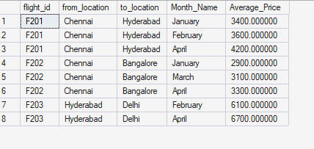

2.To display the customers who have booked the least number of tickets in ABC Airlines, identify the number of tickets booked by each customer for flights operated by ABC Airlines and determine the minimum among them. Display the profile_id, first_name, address, and the number of tickets booked as No_of_Tickets. If multiple customers have booked the same least number of tickets, display all of them. Sort the final result in ascending order based on the customer’s first name.

select
p.profile_id,
p.first_name,
p.address,
count(t.ticket_id) as No_of_Tickets
from air_passenger_profile p
join air_ticket_info t
on p.profile_id = t.profile_id
join air_flight f
on t.flight_id = f.flight_id
where f.airline_name = 'ABC Airlines'
group by
p.profile_id,
p.first_name,
p.address
having count(t.ticket_id) = (
select min(ticket_count)
from (
select count(t2.ticket_id) as ticket_count
from air_ticket_info t2
join air_flight f2
on t2.flight_id = f2.flight_id
where f2.airline_name = 'ABC Airlines'
group by t2.profile_id
) x
)
order by p.first_name;

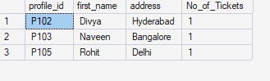

3.To display the number of flight services between locations in a month, calculate the total number of scheduled flight departure dates for each route in each month. The output should include from_location, to_location, the month name as Month_Name, and the number of flight services as No_of_Services. The results should be displayed in ascending order based on from_location, then by to_location, and then by month name.

select
af.from_location,
af.to_location,
datename(month, afd.flight_departure_date) as Month_Name,
count(afd.flight_departure_date) as No_of_Services
from air_flight af
join air_flight_details afd
on af.flight_id = afd.flight_id
group by
af.from_location,
af.to_location,
datename(month, afd.flight_departure_date),
month(afd.flight_departure_date)
order by
af.from_location,
af.to_location,
month(afd.flight_departure_date);

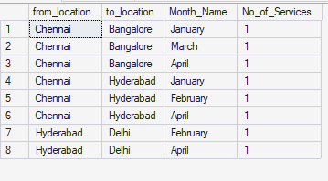

4.To display the customers who have booked the maximum number of tickets in ABC Airlines, count the number of tickets booked by each customer for flights operated by ABC Airlines and identify the highest ticket count. Display the profile_id, first_name, address, and the number of tickets booked as No_of_Tickets. If more than one customer has booked the same maximum number of tickets, display all such customers. Finally, sort the results in ascending order based on the customer’s first name.

select
p.profile_id,
p.first_name,
p.address,
count(t.ticket_id) as No_of_Tickets
from air_passenger_profile p
join air_ticket_info t
on p.profile_id = t.profile_id
join air_flight f
on t.flight_id = f.flight_id
where f.airline_name = 'ABC Airlines'
group by
p.profile_id,
p.first_name,
p.address
having count(t.ticket_id) = (
select max(cnt)
from (
select count(ticket_id) as cnt
from air_ticket_info
group by profile_id
) x
)
order by p.first_name;

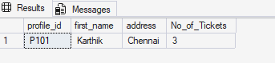

5. Write a query to display the number of tickets booked from Chennai to Hyderabad. The query should display passenger profile_id, first_name, last_name, flight_id, departure_date, and number of tickets booked as No_of_Tickets. Display the records sorted in ascending order based on profile_id and then by flight_id and then by departure_date.

select
p.profile_id,
p.first_name,
p.address,
count(t.ticket_id) as No_of_Tickets
from air_passenger_profile p
join air_ticket_info t
on p.profile_id = t.profile_id
join air_flight f
on t.flight_id = f.flight_id
where f.airline_name = 'ABC Airlines'
group by
p.profile_id,
p.first_name,
p.address
having count(t.ticket_id) = (
select max(cnt)
from (
select count(ticket_id) as cnt
from air_ticket_info
group by profile_id
) x
)
order by p.first_name;

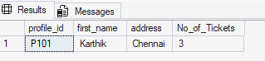

6.Write a query to display flight id, from location, to location, and ticket price of flights whose departure is in the month of April

select
af.flight_id,
af.from_location,
af.to_location,
afd.price
from air_flight af
join air_flight_details afd
on af.flight_id = afd.flight_id
where month(afd.flight_departure_date) = 4;

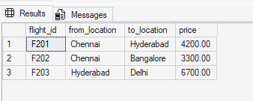
7Write a query to display the average cost of the tickets in each flight on all scheduled dates. The query should display flight_id, from_location, to_location, and average price as Price. Display the records sorted in ascending order based on flight_id, then by from_location, and then by to_location.

select
af.flight_id,
af.from_location,
af.to_location,
avg(afd.price) as Price
from air_flight af
join air_flight_details afd
on af.flight_id = afd.flight_id
group by
af.flight_id,
af.from_location,
af.to_location
order by
af.flight_id,
af.from_location,
af.to_location;

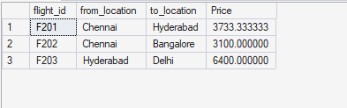

8. Write a query to display the customers who have booked tickets from Chennai to Hyderabad. The query should display profile_id, customer_name (by combining first_name and last_name with a comma in between), and the address of the customer. Give an alias to the combined name as customer_name. The query should fetch unique customers irrespective of multiple tickets booked. Display the records sorted in ascending order based on profile_id.

select distinct
p.profile_id,
p.first_name + ',' + p.last_name as customer_name,
p.address
from air_passenger_profile p
join air_ticket_info t
on p.profile_id = t.profile_id
join air_flight f
on t.flight_id = f.flight_id
where f.from_location = 'Chennai'
and f.to_location = 'Hyderabad'
order by p.profile_id;

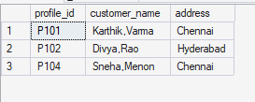

9.Write a query to display the profile_id of the passenger or passengers who have booked the maximum number of tickets. If multiple passengers have booked the same maximum number of tickets, display all such profile_id values. Display the records sorted in ascending order based on profile_id.

select profile_id
from air_ticket_info
group by profile_id
having count(ticket_id) = (
select max(cnt)
from (
select count(ticket_id) as cnt
from air_ticket_info
group by profile_id
) x
)
order by profile_id;

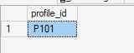
10. Write a query to display the total number of tickets booked in each flight in ABC Airlines. The query should display the flight_id, from_location, to_location, and the total number of tickets booked as No_of_Tickets. Display only those flights in which at least one ticket is booked. Display the records sorted in ascending order based on flight_id.

select
t.flight_id,
f.from_location,
f.to_location,
count(t.ticket_id) as No_of_Tickets
from air_ticket_info t
join air_flight f
on t.flight_id = f.flight_id
where f.airline_name like 'ABC%'
group by
t.flight_id,
f.from_location,
f.to_location
having count(t.ticket_id) >= 1
order by t.flight_id;

